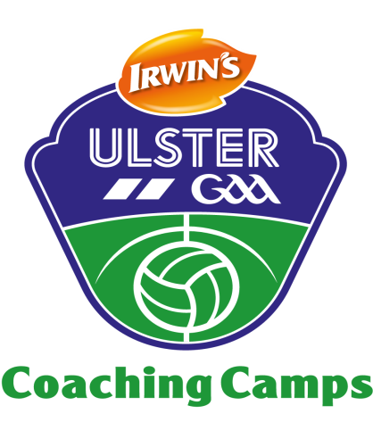

DOWN GAA CAMPA CÁSCA – EASTER GAA COACHING CAMP

Child’s Name: ...........................................................................

Age: ........................................................................................

Date of Birth: ...........................................................................

Parent Name: ...........................................................................

Contact Number (s): ..................................................................

Contact Email: ...........................................................................

I consent for my child (named above) to attend the Down GAA Easter Coaching Camp at RGU Downpatrick on Wednesday 19th and Thursday 20th April 2017, from 10am to 1pm each day.

Signed: .......................................................Date: ............................

Does your child take any prescribed or non prescribed medication?

........................................................................................................

........................................................................................................

