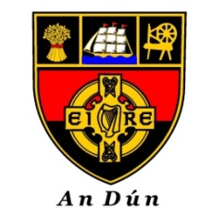

Down GAA
CUMANN LÚTHCHLEAS GAEL AN DÚIN
COISTE CHEANNAIS NA gCOMORTAISÍ

APPLICATION FOR INDEPENDENT TEAM (Amalgamation)

This form only applies to teams at U21/20, Minor and younger grades.

Please note that the name of an Independent team shall not bear the name of an Adult
Club within the County, as per Rial 6.8(b);

Applicant Clubs
Name of proposed team:
Colours

Home Venue

Competition(s)
Designated Chairperson | Name:  Mobile:  Email:
Designated Secretary | Name:  Mobile:  Email:
Designated Children’s Officer | Name:  Mobile:  Email:
Date

